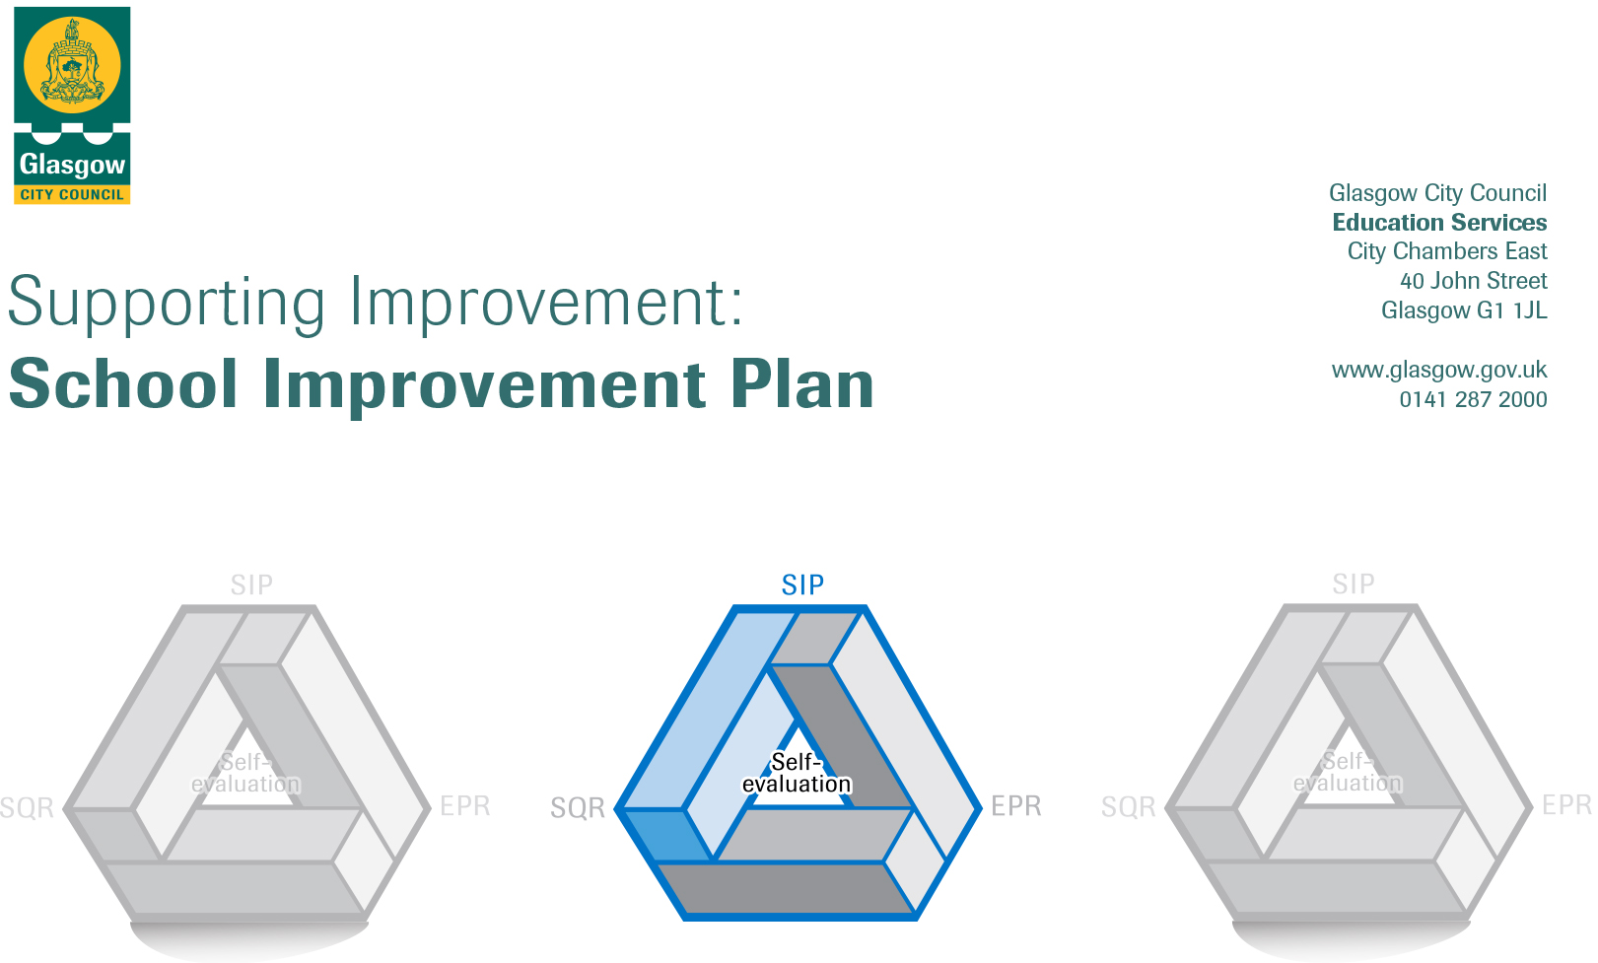

Session: 2018-19

Establishment |  | Castlemilk Day Nursery
Head of Establishment |  | Karen Henderson
Area/Local Improvement Group |  | South LIG 3
Head of Service |  | Donnie MacLeod
Area Education Officer/  Quality Improvement Officer |  | Claire Harvey

CONTENTS
1. Vision, Values and Aims
2. Summary of Self-Evaluation Process / Priorities for Improvement in the current session
3. Action Planning

Action Plan Summary for Stakeholders

1. Our Vision, Values and Aims
To offer a safe, happy, welcoming and nurturing environment. An environment where children are offered high quality experiences in a curriculum rich setting, both indoors and outdoors. A setting that meets the needs and rights of every child promotes equality and inclusion and celebrates achievements.

We work together to:
- Create an environment where children, parents, families and staff feel respected, Valued and included.
- Encourage and support children to become, Successful Learners, Responsible Citizens, Effective Contributors and Confident Individuals.
- Build an environment where children are safe, healthy, achieving, nurtured, active, respected, responsible and included. Support children in achieving their full potential.
- Promote the adoption of a healthy lifestyle and healthy life choices.
Promote positive behaviour by empowering children to take ownership of their own learning

2. Summary of our self-evaluation process.
All staff are actively involved in self-evaluation and identifying areas for improvement. Self-assessment is an essential part of evaluation and presents opportunity to assess achievements and progression. Reflections and improvements are shared with parents on our self-evaluation wall.
Self-evaluation incorporates views of children, parents, and multi-agency colleagues.
Staff, children and partners/carers are consulted and their views regularly sought through discussion, meetings, questionnaires, open days, self-evaluation wall.
Throughout planning self-evaluation is embedded where all staff/parents views are sought and looked at monthly.

Strengths identified:
The children are displaying an eagerness to learn, they are motivated and confident. They thrive in our nurturing environment, where they display positive social interactions with their peers and with adults. They are becoming successful in an environment that supports children’s choice and decision making.
We offer a range of stimulating and challenging experiences to support our children’s learning. We make good use of our outdoor area. The children enjoy visits to places of interest out with the nursery which expands their knowledge in a variety of areas. The structure of the day offers a combination of free play and adult directed play. Some of the children are involved in a pilot project (Outdoor Nursery) where they will experience the benefits of learning outdoors in the local woods.
We have excellent relationships with our children, their families and the local community, where collaborative work has been achieved.

Priorities for development:

1: Leadership of change

2: : STEM

3: : Rights based learning/Digital Learning

3. Action Planning

No. | Quality Indicator | Priority
1 | 1.3 | Leadership of change- Change structure in management team including Attainment officer and Implementing improvement and change due to additional hours for children whilst continuous improvement to quality.

Tasks to achieve priority | Timescale  and checkpoints | Evidence of Impact > (data, observation, views)
Define clear roles for management team, with shared vision for establishment. | Sept 2018  Every 3 months | Management will have a clear defined role and what is expected of their role and will be able to support staff using line management system.
Regular PDP for all staff. | Start Aug 2018 then 6 monthly review | Staff will be empowered to voice what they need accessing appropriate self-development leading to improved professional judgement.  Staff are empowered and motivated, resulting in better outcomes for children
High quality training for new and existing staff. Planning for continuous improvement. | Monthly | Improvement in learning experiences delivered to children and staff will have autonomy equipped with knowledge.  Staff challenge and support children to achieve and consistently strive towards high standards through improvement of quality.
Regular staff meeting/planning guiding/managing the process of self-evaluation for improvement. | Monthly | Staff will have a clearer up to date knowledge of establishments practice and improvements.
Look at curricular elements affected by the increase entitlement, e.g. structure of the day, core period, embedding learning. | From August 18, then monthly | Management and staff will be empowered to work as a team within rooms changing delivery of curriculum where needed.
Environment- focussing on increased number of children- lunch provision, outdoor learning, flexible areas, using community. | From August 18, then monthly | Management and staff will have robust system in place managing change due to increase in lunch numbers and effective use of outdoors will be established.

Staff leading on this priority – including partners | Resources and staff development
Head Of Centre  Depute Head, Team Leader  Attainment officer  All Child development officers | Role profile, rigorous systems in place, yearly calendar etc. event/monitoring  CPD, Twilight training, In-service on Team building, Current initiatives in establishment.  Self-evaluation, staff/planning meetings.  Baseline assessment, monitoring sheets, staff meetings, PDP paperwork

No. | Quality Indicator | Priority
2 | 2.2 | Curriculum- Develop awareness improvement in STEM using principles of inward, outward and forward thinking. Linking to Career Education Standard-Developing young workforce.

Tasks to achieve priority | Timescale  and checkpoints | Evidence of Impact > (data, observation, views)
Staff will take part in STEM training and Career education standard in-service day.  Twilight sessions on STEM /DWP using GLOW/STEM central to access resources to support STEM | August 2018 | Increase knowledge, understanding and awareness of STEM.  Knowledge of how to Increase learners’ understanding of opportunities for STEM careers.  Understanding of how to Tackle inequity in educational outcomes and promote equality in STEM areas.  How to provide a coherent framework for partnership working in relation to STEM
STEM experiences will also run in collaboration with ECO and Sustainability and outdoor learning. Linked to DWP  Stem embedded in children’s planning and evidence gathered through write, make, say and do. Clear link to curriculum areas | September 2018  On-going 2019 | Children will be able to talk confidently about STEM by linking learning to real life skills and Careers.  Clear learning pathways to STEM. Interdisciplinary learning using experiences and outcomes.
Through areas in playroom extend role play experiences of STEM using appropriate language. | September 2018  On-going 2019 | Children will be able to confidently use scientific language through their learning whilst problem solving and using critical thinking skills
Raise ambition in children through exploration of different job roles that may not have been considered. Looking at gender balance | Sept 2018  Until  June 2019 | Children will have been exposed to different types of jobs changing mind set of parents/carers and children for future learning.
Access speakers on STEM career, linking to Career Standard Embed in practice will access STEM partners. Engage parents who have STEM careers. | September 2018  June 2019 | Children will see variety of partnership working in STEM careers.
Home link STEM bags | December 2018 | Link with parents to see partnership at home.
Through information STEM wall, parents will be updated on information. Starting with “What is STEM?” Questionnaires to parents to gauge understanding and progress of STEM | August 2018  6 months review | Baseline to see improvement to children’s learning and understanding of parents.

Staff leading on this priority – including partners | Resources and staff development
Head Of Centre  Depute Head, Team Leader  Attainment officer  All Child development officers  Parents/carers  Outside agencies (Work) | Science/STEM bags are sent home to share learning with parents.  Questionnaires for parents/Staff  Baseline assessment and Graphs  individual children’s tracking  Planning/monitoring

No. | Quality Indicator | Priority
3 | 3.1 | Ensuring wellbeing, equality /inclusion- Rights based learning (Children’s voice) - incorporating digital literacy

Tasks to achieve priority | Timescale  and checkpoints | Evidence of Impact > (data, observation, views)
Training on children’s rights/ladder of participation and children’s voice. | Aug 2018 | Staff will have an understanding of how children’s rights link into education, and are the basis of what we build on. Also link current documentation.
Children’s rights included into planning/posters in establishment | Aug 2018 | Children will be at heart of planning for CFE outcomes and Pre Birth to three documents. Meeting children’s interests. Wall displays and monthly planning will evidence children’s rights.
Children Forum set up lead by Team Leader/Attainment officer | Sept/Oct 2018 | Continuity and progression in use of pupil voice across sectors within the ensuring equality and fairness.  Children will use their voice and discuss issues that affect them in establishment and in community.
Training of using digital literacy to promote children’s rights. | Dec 2018 | Staff will have better understanding of how to use digital technology in promoting children’s rights.
Collecting evidence on children’s rights commitment to connecting values and citizenship activities across learning. | March 2019 | Applying for Growing good Citizens in Glasgow award

Staff leading on this priority – including partners | Resources and staff development
Head Of Centre  Depute Head, Team Leader  Attainment officer  All Child development officers | yearly calendar etc. event/monitoring  CPD, Twilight training, In-service.  Self-evaluation, staff/planning meetings.  Baseline assessment, monitoring sheets  Children’s forum meeting

No. | Quality Indicator | Priority
4

Tasks to achieve priority | Timescale  and checkpoints | Evidence of Impact > (data, observation, views)

Staff leading on this priority – including partners | Resources and staff development

