Staff at Castlemilk Day Nursery would like to welcome back all returning children and hope they had a wonderful time off.

For all the children who were still with us over the summer, we hope you enjoyed the fun in the sun summer activities.

**Pick-ups/Emergency contacts**

Can we please remind all families that they must collect their child at the allocated pick up time? I understand that sometimes things happen and you may be a little late, but please ensure you contact the office if this is going to happen.

If someone different is coming to collect your child, could you please alert a member of management and provide a password if it is their first time collecting. It is important to note that the person collecting your child must be 16yrs or over. No child will be released to anyone under the age of 16 years old.

**Toy-Fund Tuesday**

Toy Fund Tuesday will be starting back up on Tuesday 13th September. This is a voluntary donation of £1 per child. If you are having problems paying toy fund, then please speak to a member of management. This money helps to buy resources for the children as well as pays towards birthday presents, trips, parties and other essential items needed for the children.

A member of staff will be at the front foyer on a Tuesday and Thursday to collect toy-fund. Toy fund can also be handed in at any time during the week if you miss Tuesday/Thursday.

**Dates for diary**

The nursery will be closed to **all** children on:

Friday 23rd September 2022 and Monday 26th September 2022

The nursery will be closed to **all** children on:

Friday 14th October 2022 for staff in-service day

The nursery will be closed to Term Time children on:

Monday 17th October till Friday 21st October 2022.

They will return Monday 24th October 2022

**Indoor/Outdoor**

As you are aware we are an indoor/outdoor nursery. This means the children will have access to the outdoors from 8am-5.45pm daily and can choose to be outside in a variety of different weathers. The nursery is providing outdoor clothing for your child, which is stored in a clear plastic bag with your child’s name clearly labelled.

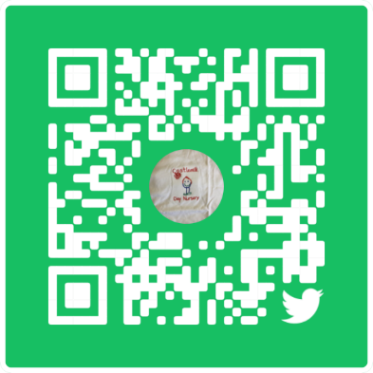

**Clothing**

Can parents/carer please make sure their child has a jacket, wellie boots and hat & scarf as the children will be outside in a variety of weather. As an indoor/outdoor nursery, children will have access to outdoors at all times.

Also any child who wears nappies, if parents could make sure their bag is stocked with nappies and wipes please.

A change of clothes, socks and indoor shoes is also required. Although children wear aprons for messy play and puddle suits outdoors, sometimes the children still need changed after having so much fun with their friends and staff. If your child has an accident and you have not provided a change of clothes, then we will have to contact you and ask that you bring clothes to nursery.

Could please ensure your child has their name on zippers, hoodies and jackets. Many children have the same item of clothing and this can prove problematic when going home as things can get mixed up.

Your co-operation is appreciated ☺

**Coming back to nursery**

As the restrictions from Covid-19 have eased, we will be starting to allow parents to come back into the nursery building to drop off/pick up your child. Parents can come into the main corridor and ring the doorbell for staff to welcome the children into the room. Unfortunately, at this time, we will not have parents within the playroom. This is to minimise the disruption to learning that would follow by having parents back in the room.

Staff will continue to do 6 monthly reviews of care plans via telephone. However, if any parent/carer would like to have a Learning and Development telephone conversation with their child’s keyworker could you please contact a member of management who will be happy to arrange this and let you know a suitable day and time for this conversation to take place.

**Website**

www.castlemilkday-nursery.glasgow.sch.uk

This is our Twitter QR code; scan it to take you to our Twitter page

**Annual data check**

We will be issuing Annual Data Checks forms within the next few weeks, it is important that we have up to date contact details in case we need to contact you in an emergency so please ensure these are completed as a matter of urgency.

If you have any concerns please don’t hesitate to get in touch with any member of management

Sam ☺