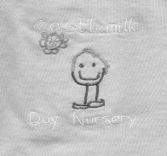

**Welcome back**

We would like to welcome back all our children and families and hope you all had a wonderful Christmas and New Year. We hope the children enjoyed their special gift they received from Santa. We look forward to working with all our families in 2020.

**Staff Changes**

Our Team leader Sam has secured an acting Depute position within a Glasgow City Council nursery. We wish Sam best wishes in her acting post, she will be missed by children and staff. Our very own CDO Carol Mills from the Arran room will be acting up as Team Leader whilst Sam is away. Meena Singh will be joining the Arran room to cover Carol’s position. Meena was previously a student within Castlemilk Day Nursery so she knows some of our children and families.

**T.V within foyer**

As you may have noticed, we have been gifted a TV in our front foyer. Using appletv we will display the children’s learning and any videos created by staff that has captured the children’s experiences.

**Dates for diary**

Term time children will finish:

Thursday 6th February 2020 and

return Thursday 13th February 2020

This is for the Mid-term break

52 week children will be off :

Friday 7th February 2020 and

Wednesday 12th February 2020 for Staff

In service training

**Lottery**

Linda runs the lottery on a weekly basis. All numbers are displayed on the janitor’s door and the winners name is announced on the Thursday after the draw. This can also be found on the Janitor’s office door.

**Hats Off!**

In April there will be a Spring play! All children who will be going to school will take centre stage in the show.

Dates will be given nearer the time

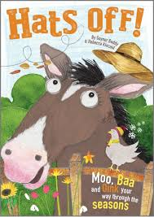

**Clothing**

Can parents/carer please make sure their child has a jacket, wellie boots and hat & scarf as the children will be outside in a variety of weather. As an indoor/outdoor nursery, children will have access to outdoors at all times.

Also any child who wears nappies, if parents could make sure their bag is stocked with nappies and wipes please.

A change of clothes, socks and indoor shoes is also required. Although children wear aprons for messy play and puddle suits outdoors, sometimes the children still need changed after having so much fun with their friends and staff. The nursery is very low on spare clothes so if your child has an accident and you have not provided a change of clothes, then we will have to contact you and ask that you bring clothes to nursery.

Your co-operation is appreciated ☺



**Toy fund**

Thank you for your continued support with Toy Fund Tuesday. This is a voluntary donation of £1 per child. Toy fund will now also be taken on a Thursday as well as a Tuesday for families who miss it at the start of the week. This money helps to buy resources for the children as well as pays towards birthday presents, trips, parties and other essential items needed for the children.

Please remember I have an open door policy. If you have any concerns please don’t hesitate to get in touch with any member of management

Karen ☺