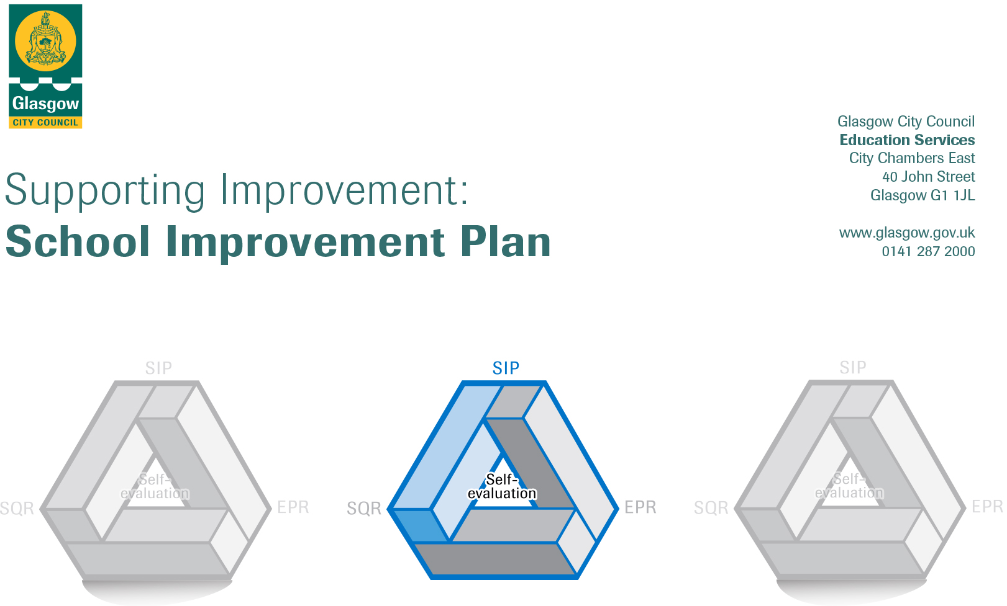

Establishment |  | Castlemilk Day Nursery
Head of Establishment |  | Karen McEwan
Area/Local Improvement Group |  | South LIG 3

Head of Service
Area ELC Manager |  | Sharon Constable

CONTENTS
1. Vision, Values and Aims
2. Summary of Self-Evaluation Process / Priorities for Improvement in the current session
3. Action Planning

Action Plan Summary for Stakeholders

1. Our Vision, Values and Aims
To offer a safe, happy, welcoming, and nurturing environment. An environment where children are offered high quality experiences in a curriculum rich setting, both indoors and outdoors. A setting that meets the needs and rights of every child promotes equality and inclusion and celebrates achievements.

We work together to:
- Create an environment where children, parents, families, and staff feel respected, Valued, and included.
- Encourage and support children to become, Successful Learners, Responsible Citizens, Effective Contributors and Confident Individuals.
- Build an environment where children are safe, healthy, achieving, nurtured, active, respected, responsible, and included. Support children in achieving their full potential.
- Promote the adoption of a healthy lifestyle and healthy life choices.
- Children’s choice is at the heart of this decision of outdoor play. Offering opportunity to play outdoors in all weather conditions.
- Promote positive behaviour by empowering children to take ownership of their own learning

2. Summary of our self-evaluation process.
At Castlemilk Day Nursery staff engage in a thorough self-evaluation process throughout the nursery year looking inwards, looking outwards and looking forwards directed by the quality assurance calendar activities. Self-assessment is an essential part of evaluation and presents opportunity to assess achievements and progression. Reflections and improvements are shared with parents, usually via our self-evaluation wall. Termly pace and challenge meetings ensure a robust self-evaluation of progress with a focus on attainment and meeting learners’ needs as well as identifying targeted support for improvement.
Staff work effectively as a team and there is a strong ethos of sharing practice, led and supported by the Senior Leadership Team. This session, staff took part in a moderation in-service day where they met with colleagues from other establishments to moderate work within literacy and numeracy outcomes.
Our self-evaluation incorporates views of children, parents, and multi-agency colleagues. All staff were offered the opportunity to reflect on improvements across the session looking inwards, looking outwards and looking forward. Staff identified strengths (How well are we doing?), relevant evidence (How do we know?) and improvement priorities (What are we going to do now?) in each area of the school improvement plan. Children and parents also have their views regularly sough through discussions, questionnaires and collecting data using online surveys. Children are also encouraged to share their learning through conversations with a member of management.
With the SLT being at the front office throughout the year, it provides opportunities for interactions with parents which offered numerous opportunities for feedback from parents.

Strengths identified:
The children are displaying an eagerness to learn, they are motivated and confident. They thrive in our nurturing environment, where they display positive social interactions with their peers and with adults. They are becoming successful in an environment that supports children’s choice and decision making.
We offer a range of stimulating and challenging experiences to support our children’s learning. We make good use of our outdoor area with free flow doors in playroom’s, placing choice at the heart of children’s decision when accessing outdoors. Our outdoors has a been a great asset during the pandemic and staff have placed an emphasis on outdoor learning for all children. Through the pandemic our nursery has had to be creative in meeting the needs of all our families. Regular development phone calls have been used to ensure clear communication with parents/carers in sharing successes and further development needs. The nursery also invested in a white board for outdoors to share updates and news with all families. Staff are using seesaw within the 3-5 room to share learning, updates and home link ideas. Digital technology has been used to capture learning and settling in for parents in the under 3 playrooms. This has allowed staff to show parents settled children and to celebrate the achievements of the children. Digital technology has also been used to create a PowerPoint for children’s rights that links Developing the Young Workforce, GIRFEC, Sustainable Development Goals, Meta Skills and UNCRC articles. This is an ongoing process that is being adapted and evaluated regularly. The children also took part in COP26 experiences, using the story of Winston of Churchill to enhance learning and understanding of sustainability. Videos and learning where shared with the LEL team as well as on Twitter.
Priorities for development:
1: Q.I 1.3- Leadership of Change (Strategic planning for continuous improvement)
2: Q.I 2.5 -Family Learning (Raising the Attainment- literacy, Numeracy workshops, curriculum days)
3: Q.I 1.4- Leadership of management and practitioners (Practitioner wellbeing and pastoral support for staff)
4: Q.I 3.1- Ensuring wellbeing, equality and inclusion- (Whole school nurturing approach)
3. Action Planning

No. | Quality Indicator | Priority – (This should be a measurable outcome)
1 | 1.3 | Leadership of Change (Strategic planning for continuous improvement)  Validate current practice and projects implemented in establishment against HGIOELC illustration. Ensuring continuity with clear vision and shared professional dialogue between practitioners. Identify and build on establishments capacity for improvement.

Tasks/Interventions to achieve priority | Staff leading on this priority – including partners | Timescale/  Checkpoints | Success Criteria – What do you predict will be the impact on learners?  (Data, observation, views)
Create calendar of programmes/events for the year for families/carers and staff professional learning. Ensure continuity in practice. | Head of Centre | August 23  Sept 23  Oct 23  Nov 23  Feb 24 | Feed back from families/carers and engagement levels increased with programmes or events happening in establishment.  Reviewed regularly and ongoing monitoring where programmes are not achieving results, the programmes will be reviewed, adapted and changed.
Identify staff talents/skills to take forward individual improvements in curricular areas | Head of Centre  Lead Practitioner Attainment | Aug 23  Nov 23  Feb 24 | Staff will be able to apply skills knowledge in specific area chosen to measure improvement. Moderation will be a key feature in measuring improvement of areas in establishment. Staff judgements, using a wide range of evidence, based on a consistent and shared understanding of standards within CFE.  Improved outcomes for children ensuring every child achieves highest standard ensuring all children has the same opportunity to succeed.  Data gathered on staff, families and children perspectives- evidence/impact.
Introduce reflective practitioner meetings weekly on learning teaching. Every Friday 3-5 and Thursday 0-3 staff. 15mins at end of day with representatives. | Depute/Team Leader | Aug 23  Sept 23  Oct 23  Nov 23  Dec 23  Feb 24  March 24  April 24  May 24 | Staff have dialogue around pedagogy and practice dilemmas and reflective practice.  The dialogue is a means to include inclusive practice in establishment.  By communicating effectively between staff, will have impact on families/carers, consistent messages will support families/carers in their children's experiences at the setting. Build and develop positive relationships.  Staff sustained shared thinking builds on the child’s learning through child interests; recasting; extending; questioning.
Promote practitioner enquiry | Led by all management,  All staff- | Aug 23  Sept 23  Oct 23  Nov 23  Dec 23  Jan 24  Feb 24  March 24  April 24  May 24 | Staff will be able to identify issues and address, further research literature resources to identify reasons/solutions, implement strategy for improvement and evaluate any changes.  Staff will be empowered and encourage to challenge and transform education, whilst developing their own practice.  It will also increase their knowledge of teaching and learning thus enabling them to make more professional and autonomous judgements and to enhance their self-esteem and professional identity.  Foster an environment of closing the attainment gap.

Looking Forwards - Next Steps
(Not to be completed until priority achieved)

No. | Quality Indicator | Priority – (This should be a measurable outcome)
2 | 2.5 | Family Learning (Raising the Attainment- literacy, Numeracy workshops, curriculum days)

Tasks/Interventions to achieve priority | Staff leading on this priority – including partners | Timescale/  Checkpoints | Success Criteria – What do you predict will be the impact on learners?  (Data, observation, views)
Consistency put into place of family partnership programmes. Calendar of events | Head of Centre  Lead Practitioner Attainment  CDO-Kirstin  CDO- Leigh | Aug 23  Sept 23  Oct 23  Nov 23  Dec 23  Jan 24  Feb 24  March 24  April 24  May 24 | Increase knowledge, understanding and awareness of family partnership.  Knowledge of how to Increase family’s participation in their child’s life.  Understanding of the benefits of partnership working and educational outcomes to promote learning.  Children will benefit from this partnership. Children’s confidence will be boosted and there is a positive impact on their development. Links to the Getting it Right for Every Child (GIRFEC) wellbeing indicators. Will be demonstrated through how eating well and enjoying positive eating experiences contribute to children being  safe, healthy, achieving, nurtured, active, respected, responsible and included.
Through parent partnership wall, parents will be updated on information. | Lead Practitioner Attainment | September 2023  June 2024 | Baseline, then track improvements to children’s learning and understanding of parent’s engagement. Through data will be able to compare evidence.
Numeracy workshops- in form of Nattering numbers around a tea and cake theme.  Numeracy stall at front entrance to greet parents/families and offer Curriculum evening. | Lead Practitioner Attainment  Leader of Early Learning  CDO-Susan  CDO-Elaine  CDO-Jade | November 2023  June 2024 | Higher volume of engagement from parents at workshops.  Parents learned new numeracy skills to implement with their children at home.  Parents/carers feel valued and how they can contribute to their child learning.
Literacy Workshops-  Promote Rhyme and story time on a Friday.  Literacy stall at front entrance to greet parents/families and offer Curriculum evening. | Lead Practitioner Attainment  Leader of Early Learning  CDO-Kirstin  CDO-Elaine  CDO-Anne  CDO-Maria | October 23  March 24 | Tracking and monitoring the levels of attendance of parents/carers.  Parents/carers will gain knowledge of how to Increase family’s participation in their child’s life.  Understanding of the benefits of partnership working and educational outcomes to promote learning.  Children’s confidence will be boosted and there is a positive impact on their development. Links to the Getting it Right for Every Child.
Outreach events from NHS and voluntary agencies. Wednesday morning. | Depute Head of Centre  Lead Practitioner Attainment | Nov 23  Feb 24  April 24  May 24 | Parents/carers will benefit from information events on budgeting, healthy eating and completing relevant forms.
Enhance engagement with a focus on EAL learners and families. | Depute Head of Centre  Lead Practitioner Attainment | Jan 24  Feb 24  March 24  April 24  May 24 | Create music team to support in songs in different languages. Families involved in reading and singing in their own language. More engagement from EAL families. Widening staff skills and expertise on other languages. More inclusion for EAL children.  Their will be more EAL print and an emphasis placed on religious education celebrating all cultures which will be evident in playrooms.

Looking Forwards - Next Steps
(Not to be completed until priority achieved)

No. | Quality Indicator | Priority – (This should be a measurable outcome)
3 | Q.I 1.4 | Leadership of management and practitioners (Practitioner wellbeing and pastoral support for staff)

Tasks/Interventions to achieve priority | Staff leading on this priority – including partners | Timescale/  Checkpoints | Success Criteria – What do you predict will be the impact on learners?  (Data, observation, views)
Set Up Monthly One-On-Ones or Drop-in sessions for any concerns.  Advice on further GCC supports at meeting, to support a resilience staff team. | Head or Depute Head of Centre | Aug 23  Sept 23  Oct 23  Nov 23  Dec 23  Jan 24  Feb 24  March 24  April 24  May 24 | Fostering Staff wellbeing is good for staff and the establishment. Promoting wellbeing can help prevent stress and create positive working environments where staff and the establishment can thrive. Good health and wellbeing can be a core enabler of staff engagement and establishment performance. There will be an open culture towards supporting mental health  Staff will feel valued and invested. Reduced absences from work in relation to sickness (both short term and long term).  To support children feeling valued and nurtured staff will have experience of feeling nurtured.
Support staff with walking lunch group | Management Team  All staff | October 23  Feb 24  April 24  June 24 | There is a growing amount of research about the benefits of spending time outside, five- or 10-minutes walking around the block at lunchtime can improve wellbeing. Being active is not only great for physical health and fitness.
Monthly Lunch with feedback boxes where staff can anonymously share ideas for improving practice and wellbeing | Management Team  All staff | October 23  Feb 24  April 24  June 24 | Promotes team work, talking to each other through organisational techniques for lunch.  Feedback box allows staff to contribute own ideas.
Leadership behaviours to include- compassionate management.  - Adapt to change.  - Embracing a coaching mindset.  - Leaders practice effective listening.  - Cultivating an inspiring vision. | All Management Team | October 23  March 24 | Review work demands regularly, ensure staff have a say in how they work and Provide opportunities for staff to influence how work within the centre is carried out.  Encourage feedback from staff about management procedures and working relationships. Staff will be included to review and develop policies and practices as a team (for example, ensuring that your setting is free from bullying and harassment, discrimination and racism).

Looking Forwards - Next Steps
(Not to be completed until priority achieved)

No. | Quality Indicator | Priority – (This should be a measurable outcome)
4 | Q.I 3.4 | Ensuring wellbeing, equality and inclusion- (Whole school nurturing approach)

Tasks/Interventions to achieve priority | Staff leading on this priority – including partners | Timescale/  Checkpoints | Success Criteria – What do you predict will be the impact on learners?  (Data, observation, views)
All staff to complete Early years on line learning modules designed by Glasgow psychological service. Attachment modules 1,2,3 completed so far. | Management Team  All staff | August 23  Nov 23  Feb 24  April 24 | As part of the Nurturing City, our establishment is committed to ensuring that all of our staff are nurture trained on the nurture principles. This would be evident through playroom environments and staff approach which supports attachment and attunement.
Nurture Module 4, 5, 6 | Management Team  All staff | Aug 23 | Children will be more confident connecting with others, to build important relationships, and be able to develop a sense of self-worth. them learn, play and communicate – and it is enabling children to thrive.  Staff have developed a nurturing approach and there is a shared understanding of what is meant by a nurturing approach in a nursery context.  Children feel safe in their environment that supports them to flourish.
Child Development Module 7,8,9,10,11 | Management Team  All staff | October 23 | Staff will have a deeper understanding and knowledge of child development. There will be a focus on how children of at all stages of development. Children will benefit from staff’s expertise and knowledge in proving experiences/resources at the child’s developmental stage. Staff will be better equipped to support families with advice on different stages of child development.
Language and communication development module 12,13,14,15 | Management Team  All staff | Feb 24 | Staff will have deeper understanding of the first 3 years of a child’s life is when the brain is developing and maturing. It is the most intensive period for acquiring speech and language skills. Staff will be equipped to offer stimulating environments to promote language skills. The playroom’s will be rich with sounds, sights, and staff will offer a consistent exposure to the speech and language of others. Staff will support parents at home with literacy bags to promote language.  families will have opportunity to develop language skills with children and early intervention work will be evident in conjunction with families.  Children will be confident in using their voice and building/extending vocabulary.
Implications for Practice module 16 | Management Team  All staff | May 24 | Staff will have a clear understanding of the impact completing modules will have on current practice and improving outcomes for children and families. Self-evaluation will be weaved through all modules.  Playroom environments, staff practice and interactions should show evidence of training. Monitoring will highlight the evidence.

Looking Forwards - Next Steps
(Not to be completed until priority achieved)

