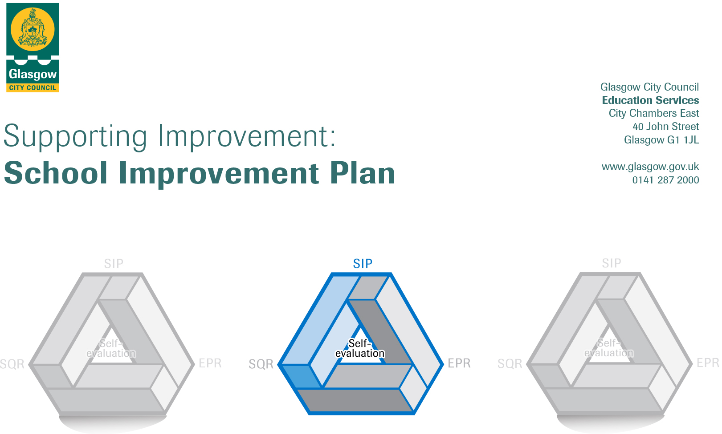

Session: 2019-2020

Establishment |  | Castlemilk Day Nursery
Head of Establishment |  | Karen Henderson
Area/Local Improvement Group |  | South LIG 3
Head of Service |  | Donnie MacLeod
Area Education Officer/  Quality Improvement Officer |  | Claire Harvey

CONTENTS
1. Vision, Values and Aims
2. Summary of Self-Evaluation Process / Priorities for Improvement in the current session
3. Action Planning

Action Plan Summary for Stakeholders

1. Our Vision, Values and Aims
To offer a safe, happy, welcoming and nurturing environment. An environment where children are offered high quality experiences in a curriculum rich setting, both indoors and outdoors. A setting that meets the needs and rights of every child promotes equality and inclusion and celebrates achievements.

We work together to:
- Create an environment where children, parents, families and staff feel respected, Valued and included.
- Encourage and support children to become, Successful Learners, Responsible Citizens, Effective Contributors and Confident Individuals.
- Build an environment where children are safe, healthy, achieving, nurtured, active, respected, responsible and included. Support children in achieving their full potential.
- Promote the adoption of a healthy lifestyle and healthy life choices.
Promote positive behaviour by empowering children to take ownership of their own learning

2. Summary of our self-evaluation process.
All staff are actively involved in self-evaluation and identifying areas for improvement. Self-assessment is an essential part of evaluation and presents opportunity to assess achievements and progression. Reflections and improvements are shared with parents on our self-evaluation wall.
Self-evaluation incorporates views of children, parents, and multi-agency colleagues.
Staff, children and partners/carers are consulted and their views regularly sought through discussion, meetings, questionnaires, open days, self-evaluation wall.
Throughout planning self-evaluation is embedded where all staff/parents views are sought and looked at monthly.

Strengths identified:
The children are displaying an eagerness to learn, they are motivated and confident. They thrive in our nurturing environment, where they display positive social interactions with their peers and with adults. They are becoming successful in an environment that supports children’s choice and decision making.
We offer a range of stimulating and challenging experiences to support our children’s learning. We make good use of our outdoor area. The children enjoy visits to places of interest out with the nursery which expands their knowledge in a variety of areas. The structure of the day offers a combination of free play and adult directed play. Some of the children are involved in a pilot project (Outdoor Nursery) where they will experience the benefits of learning outdoors in the local woods.
We have excellent relationships with our children, their families and the local community, where collaborative work has been achieved.

Priorities for development:

1: Leadership of Learning

2: : Family Learning

3: : Ensuring children’s progress, Numeracy/Digital Learning

3. Action Planning

No. | Quality Indicator | Priority
1 | 1.2 | Leadership of learning- Delivering High quality learning experiences through delivery of 1140hrs. Empowering children and practitioners to lead on own learning.

Tasks to achieve priority | Timescale  and checkpoints | Evidence of Impact > (data, observation, views)
Leaders empower practitioners and actively develop leadership at all levels to improve the overall capacity of the setting. | From August 19, then monthly | Staff will take lead roles within curriculum areas and share practice at in service days.
Practitioners take lead from the child when implementing learning. Curriculum plans have clear leaning intensions and children have a knowledge/understanding of their learning. | From August 19, then monthly | Staff challenge and support children to achieve and consistently strive towards high standards through improvement of quality.  Evidence through children’s learning conversations show clear link to children’s learning.  Effective questioning (HOTS) used by all practitioners to support children’s critical thinking skills.
High quality training for new and existing staff. Understanding of early year’s pedagogy and clear understanding of how children learn. | From August 19, then monthly | Improvement in learning experiences delivered to children and staff will have autonomy equipped with knowledge. Induction programme/Tapestry programme will see practitioners with a shared understanding of early years pedagogy and assessment.
Regular staff meeting/planning, Moderation, guiding/managing the process of self-evaluation for improvement. Whilst tracking progression. | Monthly | Staff will have a clearer up to date knowledge of establishments practice and improvements. Link curriculum planning and show children’s progression through moderation.
Look at curricular elements affected by the increase entitlement, e.g. structure of the day, core period, embedding learning. | From August 19, then monthly | Management and staff will be empowered to work as a team within rooms changing delivery of curriculum where needed.
Environment- focussing on increased number of children- lunch provision, outdoor learning, flexible areas, using community. | From August 19, then monthly | Management and staff will have active areas for children’s engagement in playrooms.  Room monitoring will provide clear evidence of effective use of areas.

Staff leading on this priority – including partners | Resources and staff development
Head Of Centre  Depute Head, Team Leader  Attainment officer  All Child development officers | CPD, Twilight training, In-service, CDO induction programme, Tapestry programme,  Self-evaluation, staff/planning meetings.  Baseline assessment, monitoring sheets, staff meetings, PDP paperwork,Moderation

No. | Quality Indicator | Priority
2 | 2.5 | Family Learning- To embed programs to support parents/families at home with children in numeracy and literacy.  Workshops on health, budgeting, positive parenting and NHS workshops. In conjunction with Health centre and outreach services.

Tasks to achieve priority | Timescale  and checkpoints | Evidence of Impact > (data, observation, views)
LPA and TL will work closely with staff tracking/monitoring parent partnership programmes to see impact and engagement levels of families. | Jan 2019 | Increase knowledge, understanding and awareness of family partnership.  Knowledge of how to Increase family’s participation in their child’s life.  Understanding of the benefits of partnership working and educational outcomes to promote learning.  Children will benefit from this partnership. Children’s confidence will be boosted and there is a positive impact on their development. Links to the Getting it Right for Every Child (GIRFEC) wellbeing indicators. Will be demonstrated through how eating well and enjoying positive eating experiences contribute to children being  safe, healthy, achieving, nurtured, active, respected, responsible and included.
Cook along sessions on a budget, with support from a chef. Cooking experiences will also run in collaboration with ECO, Sustainability and outdoor learning. Children will use own grown produce with parents. | September 2019  On-going 2020 | Children will be able to talk confidently about cooking/ingredients by linking learning to real life skills and Careers.  Clear learning pathways to healthy eating. Interdisciplinary learning using experiences and outcomes.  Parents are engaged in workshops with increased knowledge of providing nutritious diet on a budget. Self-evaluation comments will evidence children and families feel valued and included.
CPD training for staff on Care Inspectorate document “Food Matters” | August 2019 | Practitioners will have knowledge of document and impact on practice.
Outing to Birgidale complex with parents and children for interactive cooking experience. (Community venue run by volunteers)  Outing to restaurant to support in social skills.  Access speakers who are in hospitality career, linking to Career Standard and Care Inspectorate document “Food Matters”. | September 2019  On-going 2020 | Children will be aware of eating well and have good eating habits and social skills.  Children will voluntary try new foods. This will help change mind set of parents/carers that convenience food can be healthy foods. Children and parents/carers are given the opportunity to participate in food activities together (cooking sessions, visits).
Home link Kerry the Koala the chef bags.  Engage parents who have Hospitality careers. | Sept 2019  Until  June 2020 | Link with parents to see partnership at home.
Through parent partnership wall, parents will be updated on information. | September 2019  June 2020 | Baseline to see improvement to children’s learning and understanding of parent’s engagement.
Numeracy workshops- in form of Nattering numbers around a tea and cake theme | November 2019  June 2020 | Higher volume of engagement from parents at workshops.  Parents learned new numeracy skills to implement with their children at home.
Literacy- Live bed time stories- links directly into digital literacy. Different narrators reading story for example police, parent, staff, health professional which will be recorded and put on our new website. | November 2019  On-going 2020 | It has promoted language and literacy development building on children’s vocabulary.  Parents engage with their child listening to stories at night.  A passion for story reading is embedded in home life.  Increased children’s motivation and promoted parent involvement is noticed.  Children will gain knowledge and have an increased bank of words.

Staff leading on this priority – including partners | Resources and staff development
Head Of Centre  Depute Head, Team Leader  Attainment officer  All Child development officers  Parents/carers  Outside agencies (Work) | Kerry the Koala chef bags are sent home to share learning with parents.  Questionnaires for parents/Staff  Baseline assessment and Graphs  individual children’s tracking  Planning/monitoring  CPD training  Literacy and Numeracy resources

No. | Quality Indicator | Priority
3 | 3.2 | Ensuring children’s progress- Numeracy/Digital Learning

Tasks to achieve priority | Timescale  and checkpoints | Evidence of Impact > (data, observation, views)
CPD training on using Numeracy trackers 1 and 2 for staff. | Aug 2019 | Staff will have an understanding of numeracy progression pathways at early level.  Staff can confidently track children’s numeracy from beginning to end.  Staff has a clear knowledge of provocations/opportunities to provide on a regular daily/weekly/spontaneous to make clear depth of opportunity each child needs to develop that aspect in that context.
Numeracy work shop –nattering numbers | November 2019  June 2020 | Higher level of engagement of parents attending workshops.  Links directly into family engagement.
I pad CPD training  Digital strategy | September 2019  June 2020 | Create as whole staff team approach digital learning strategy.  CPD accessed through CPD manager in conjunction with CGI.  In house training twilight.  All practitioners will be confident in using I pads and will be part of curriculum learning for children.
Digital recording using I pads | September 2019  June 2020 | Embedded into children’s learning.
Digital day sharing practice | May 2019 | Sharing practice event for parents. Children will confidently demonstrate digital learning and use digital language.

Staff leading on this priority – including partners | Resources and staff development
Head Of Centre  Depute Head, Team Leader  Attainment officer  All Child development officers | yearly calendar etc. event/monitoring  CPD, Twilight training, In-service.  Self-evaluation, staff/planning meetings.  Baseline assessment, monitoring sheets  Children’s forum meeting

No. | Quality Indicator | Priority
4

Tasks to achieve priority | Timescale  and checkpoints | Evidence of Impact > (data, observation, views)

Staff leading on this priority – including partners | Resources and staff development

