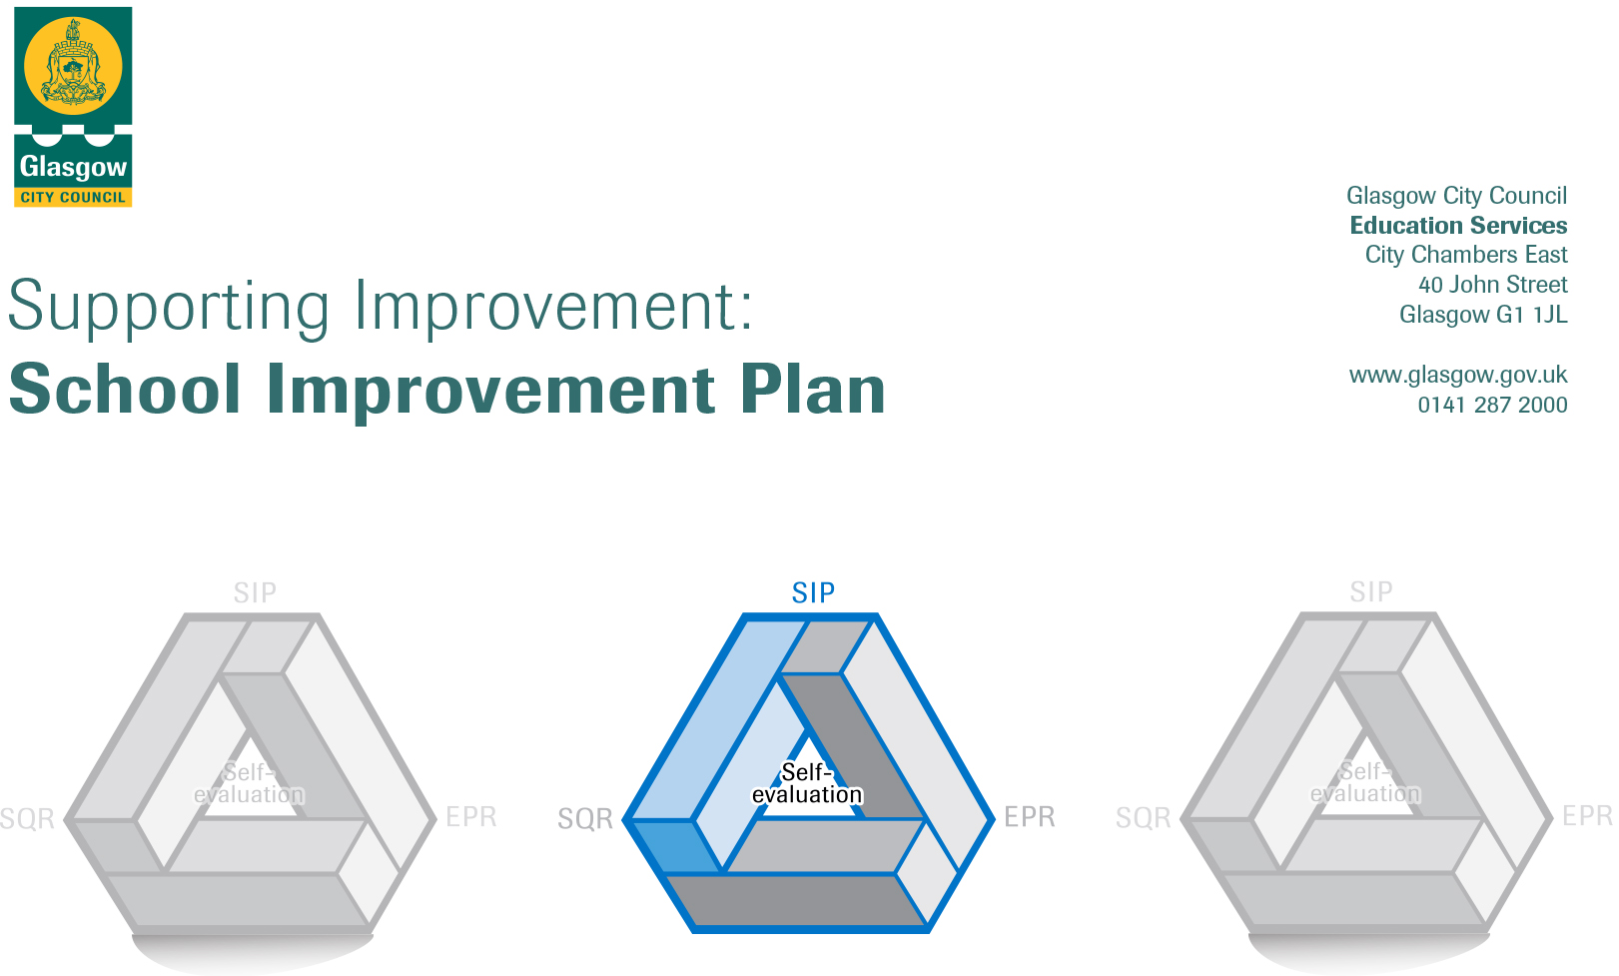

Establishment |  | Castlemilk Day Nursery
Head of Establishment |  | Karen Henderson
Local Improvement Group |  | South LIG 3
Head of Service |  | Donnie MacLeod
Area Education Officer/
Quality Improvement Officer/Link Officer

CONTENTS
1. Vision, Values and Aims
2. Summary of Self-Evaluation Process / Priorities for Improvement in the current session
3. Additional Monies Spend Summary of Consultation Processes
4. Action Planning

Action Plan Summary for Stakeholders

1. Our Vision, Values and Aims
To offer a safe, happy, welcoming, and nurturing environment. An environment where children are offered high quality experiences in a curriculum rich setting, both indoors and outdoors. A setting that meets the needs and rights of every child promotes equality and inclusion and celebrates achievements.

We work together to:
- Create an environment where children, parents, families, and staff feel respected, Valued, and included.
- Encourage and support children to become, Successful Learners, Responsible Citizens, Effective Contributors and Confident Individuals.
- Build an environment where children are safe, healthy, achieving, nurtured, active, respected, responsible, and included. Support children in achieving their full potential.
- Promote the adoption of a healthy lifestyle and healthy life choices.
- Children’s choice is at the heart of this decision of outdoor play. Offering opportunity to play outdoors in all weather conditions.
- Promote positive behaviour by empowering children to take ownership of their own learning

2. Summary of our self-evaluation process.
All staff are actively involved in self-evaluation and identifying areas for improvement. Self-assessment is an essential part of evaluation and presents opportunity to assess achievements and progression. Reflections and improvements are shared with parents, usually via our self-evaluation wall but due to Covid- 19 we have had to be creative. Challenge questions have been uploaded to seesaw and a QR code has been attached to our outdoor display board for all other parents to scan.
Our self-evaluation incorporates views of children, parents, and multi-agency colleagues. Staff, children and partners/carers are consulted, and their views regularly sought through discussion, meetings, questionnaires, open days, self-evaluation wall. As stated previously due to Covid-19 alternative collection of data
Throughout planning self-evaluation is embedded where all staff/parents’ views are sought and looked at monthly.

Strengths identified:
The children are displaying an eagerness to learn, they are motivated and confident. They thrive in our nurturing environment, where they display positive social interactions with their peers and with adults. They are becoming successful in an environment that supports children’s choice and decision making.
We offer a range of stimulating and challenging experiences to support our children’s learning. We make good use of our outdoor area with free flow doors in playroom’s, placing choice at the heart of children’s decision when accessing outdoors. Our outdoors has a been a great asset during the pandemic and staff have placed an emphasis on outdoor learning for all children. Through the pandemic our nursery has had to be creative in meeting the needs of all our families. Telephone calls have been a promote feature to ensure consistency in contact still maintained. The nursery also invested in a white board for outdoors to share updates and news with all families. Digital technology was used for home learning to be shared with families and a platform for families to keep in contact.

Priorities for development:
1: Q.I 1.1- Self-evaluation for self- improvement (Practitioner involvement in self-evaluation practice/moderation, parental involvement)

2: Q.I 2.3- Learning, teaching and assessment (Literacy trackers, Phonological awareness, tracking and monitoring).

3: Q.I 3.3- Developing skills for lifelong learning (Sustainability, COP26)
4:

3. Additional Monies Spend Summary of Consultation Processes
Rationale for Spend:

Measures/Evidence for Impact (data, observation, views):
1:

2:

3:

4:

4. Action Planning

No. | Quality Indicator | Priority
1 | 1.1 | Self-evaluation for self- improvement (Practitioner involvement in self-evaluation practice/moderation, parental involvement)

Tasks to achieve priority | Timescale  and checkpoints | Evidence of Impact > (data, observation, views)
Robust self-evaluation monitoring, recording, | Sept 2021  Oct 2021  Nov 2021  Dec 2021  Jan 2022  Feb 2022  March 2022  April 2022  May 2022  June 2022 | Self-evaluation is an ongoing process supporting all staff to analyse their work. The quality indicators and challenge questions from “How Good is Our Early Learning and Childcare?” are used to support self-evaluation and reflection across our establishment. The collaborative approach is aimed to see if programmes implement such as literacy, sustainability and COP26 are bringing about positive change.  A quality assurance calendar of self- evaluation using challenge questions will be devised for the year focusing on our current SIP. Links to UNCRC and National Care Standards will be included, ensuring at the fore front of practice.  Impact would be data collated would support inform future practice.  The impact of Covid-19 will be woven throughout self-evaluation and as a continues process adaptions/changes made in meeting children, family’s needs in line with current guidelines.  Priorities in education services will be aligned in how we continue to plan for improvement.  Key question 5, “How good is our care and support during the  Covid-19 pandemic?” Will continue to be used until further guidance. Our self-evaluation will run alongside the Care Inspectorate, “A quality framework for daycare of children, childminding and school-aged childcare”. The quality framework will support nursery evaluating our own performance.
self-evaluation leadership, working group, children and Partners | Sept 2021  Oct 2021  Nov 2021  Dec 2021  Jan 2022  Feb 2022  March 2022  April 2022  May 2022  June 2022 | Covid-19 has impacted on the way we collate data for improvement particularly when reaching out to families. When looking at leadership and our approach to improvement we aim to delegate leadership roles within staff team. Impact would be staff take ownership of self-evaluation and see it as an integral part of their role. A working group of self-evaluation will meet every monthly collating evidence in relation to quality assurance calendar, with identified steps for improvement.  Challenge questions will be distributed each month to parents via seesaw to seek views of different aspects of our SIP in conjunction will be on line questionnaires via survey monkey. The feedback will inform practice and future developments.  Children will be consulted through their children rights forum ensuring UNCRC article 12 is enacted.  The group of practitioners.
Moderation | Oct 2021  Nov201  Jan2022  Mach 2022  May 2022 | Moderation supports high quality learning and identifies next steps for individual children and nursery.  Moderation will take place after each children’s plan, with peer assessment of children’s profiles. This instils confidence in staff abilities whist given a sound knowledge of moderation. All staff will engage in moderation activities, continuously evaluating improvement.  The focus will look at monitoring tracking children’s progress whilst evaluating quality of children’s learning.
Data collating | Sept 2021  Nov 2021  Feb 2022  May 2022 | Training will be delivered at Aug Inset day on collating data. Staff will gain sound knowledge on how data informs practice and aligns with NIF and GCC priorities.  Demographic Data-  Perception data-  Process data-  Children’s learning data-  The data will give us a more holistic insight when gathering self-evaluation for improvement.

Staff leading on this priority – including partners | Resources and staff development
Team Leader- Leading working group  Head of Centre  All Staff  Children/Families | Data Training  HGIOELC  Challenge questions  Moderation paperwork  Survey Monkey  Data, Attendance, ethnic, cultural background, ASN, Learning Teaching, Stakeholder views.

No. | Quality Indicator | Priority
2 | 2.3 | Learning, teaching and assessment (Literacy trackers, Phonological awareness, tracking and monitoring).

Tasks to achieve priority | Timescale  and checkpoints | Evidence of Impact > (data, observation, views)
August Inset day, all staff will receive training on GCC literacy for all trackers (CFE and Birth to three). This will be delivered by our two-literacy champion who has worked closely with LEL member of staff and the Head of Centre. | Aug 2021  Nov2021  Feb2022  May2022  June 2022 | Closing the attainment gap is a key driver in Scottish education and one which can be assisted through literacy to help create a culture of aspiration in families Raising attainment and achievement through Glasgow’s improvement challenge will still be the focus. The framework makes clear link CFE benchmarks. Improvement Framework and the Scottish Attainment Challenge aim to reach the most disadvantaged families and deliver early intervention and prevention programmes such as literacy. Impact of Covid-19 has seen a loss in literacy due to children spending more time on digital technology or watching TV. The aim is for children to become more fluent in language by being exposed to a wide range of vocabulary through conversation. This will also support children’s wellbeing through high quality interactions.  Questionnaires will be produced to gauge staff knowledge before and after training. Parental questionnaires via seesaw will also gauge parent perception of literacy. Seesaw will be used as a method due to Covid-19 restrictions.  Monitoring check points of use of trackers. Through children’s individual literacy trackers data will record children’s progress. Impact should give a holistic look at progression gauging if children are on track to achieving early level by end of primary1. This evidence will be collated and recorded June 2022 ACES.
Literacy audit of environments, Baseline assessment | Aug 2021  Nov 2021  March2022  June 2022 | Audit of all rooms will provide information needed for adjustments in room to support a rich literacy environment. high quality ELC is identified as a factor in improved literacy skills and reducing inequalities for children (Scottish Government, 2019).  Audit of resources for children provocations in literacy. To support delivery in literacy experiences with the focus on strengthen the quality of current provision.  Identified literacy champions will have the view of sharing good practice with peers and external partners.  Accurate staff peer assessment will lead to an increased awareness of high-quality interactions.  Baseline assessments, observation and monitoring proformas will be used before and after implementation and change, in gathering data on literacy. Accurate observations leading to appropriate target setting and next steps in  Learning.
Create whole nursery Literacy strategy/policy to ensure consistent approach with literacy. | Sep 2021  Feb 2022 | The impact of literacy strategy/policy is a consistent approach delivering literacy. This will strengthen outcomes for children having a sustained impact into later learning.  Improved approaches to teaching and learning Consistent approaches to planning, learning, teaching and assessment that ensure progression.
Early intervention and use of Data. | Sept 2021  Nov 2021  Feb 2022  May 2022 | In service day, staff will gain knowledge on different types of Data and how data can be analysed effectively to plan interventions.  In closing the poverty related attainment gap early intervention is key meeting excellence and equity.  Part of Glasgow priorities, Nurture principles will be at the heart of returning children to nursery. All staff will be familiar with nurturing Nurture principle 4- Language is vital means of communication will be evident in early intervention. This will be done through additional language service, Psychological service, speech and language being accessed.  In meeting needs children’s diverse abilities, culture backgrounds, life circumstances will be considered when accessing early intervention support.  Staff will have increased confidence in professional dialogue when meeting children needs. As GCC move towards a nurturing city and impact of Covid- 19 where lost time in nursery, a focus on meeting children’s needs will remain at fore front particularly children who have an additional support need.
Create robust system of delivering phonological awareness alongside literacy tracker | Sept 2021  Oct 2021  Nov 2021  Dec 2021  Jan 2022  Feb 2022  March 2022  April 2022  May 2022 | Phonological awareness will not be used in isolation interlinks with literacy trackers. practitioners will look backwards and forwards in order to identify gaps and next steps for children.  Our additionality CDO will oversee phonological awareness group. A timetable of lessons plans and dates will be devised for individual groups.  Groups will be split for lessons into school leavers and remaining children which will measure impact.  A big focus will be on rhyme as this will support children on there progression to read. Targeting smaller groups of children will offer a nurturing environment where children are more relaxed and readier to learn. This links into UNRC, article 12 where child’s voice will be prominent and heard.  There will be a children’s rights group that will meet monthly to discuss issues or concerns they may have. Impact will be children exposed to a talking group, where their voice is used building on their own confidence and vocabulary.

Staff leading on this priority – including partners | Resources and staff development
Karen Henderson- Head of Centre  Allison Leask- Literacy Champion  Danya Jamil- Literacy Champion  Additionality CDO- phonological awareness/children’s rights group  All Staff  LEL | Literacy training using Trackers recording Data  Literacy Counts Resource/Trackers  Phonological Trackers  Birth to three Trackers  Monitoring/Moderation paperwork  Pace and challenge meetings

No. | Quality Indicator | Priority
3 | 3.3 | Developing skills for lifelong learning (Sustainability, COP26)

Tasks to achieve priority | Timescale  and checkpoints | Evidence of Impact > (data, observation, views)
To use Learning for Sustainability (LfS) self-evaluation and improvement framework, intended to complement wider conversations around whole nursery evaluation and improvement. | Aug 2021  May 2022 | Looking inwards, outwards and forwards, we are building a shared understanding of LfS and its relevance to our children. Evidence recorded through our self-evaluation. Aiming to achieve Gold Acorn Award for LfS. Links directly with children’s Global rights.  It also encompasses GCC themed area of work COP26- Towards Better Future, BGE.
Using Winston of Churchill: One Bear's Battle Against Global Warming to learn about SDG 13- Climate Change. To support all children and young people to be caring, responsible and active global citizens developing the skills, knowledge and attitudes they need as adults to enjoy living in harmony with others, in a just and sustainable world. Adopt a Polar Bear from WWF to teach the children about Climate Change and COP26 | Aug 2021  Oct 2021  Dec 2021 | Evidence shows LfS themes and approaches are embedded or emerging in the four contexts for learning.  All practitioners demonstrate sustainability in their practice and all Children receive their entitlement to learning for sustainability. (CFE) Children engage in motivating and relevant interdisciplinary activities relating to topical LfS and COP26 themes. LfS is being used to promote skills for learning, life and work including leadership and higher order thinking skills. Our children contribute effectively to the life of the school and wider community. Children’s achievements are recorded, recognised and accredited, where appropriate.  Moderation activities, children tracking should show clear links to LfS.
Our nursery will make partnerships with local organisations, businesses and national third sector organisations including charity and voluntary groups.  Aim for some parents to be involved in our sustainability work through volunteering for one-off events. | Oct 21  Jan 22  May 22 | Impact would be our nursery effectively engages with partners to promote a coherent whole nursery approach to LfS. To have a clear strategy for growing existing LfS partnerships and establishing new ones. The nursery is recognised for the active role it plays in personal development and active citizenship. LfS activities have significantly enhanced parental and community engagement. Relationships between staff, Children, parents and wider community groups are positive and mutually beneficial. Evidence through parent, children, outside agency interaction data collected from Aug 21 to May 22.
Ensuring wellbeing, equality and inclusion Raising attainment and achievement Creativity and employability (DYW).  Uphold the child’s entitlement to learning about sustainable development and their right to UNCRC Article 29 (right to education). Using Dr Seuss book, The Lorax to learn about sustainability. | Sept 2021  Jan 2022  Mar 2022  June 2022 | LfS activities support our ethos and culture of participation and inclusion (linked to GIRFEC and the UNCRC). There is a strong focus on learner voice in decision-making and planning. We value and celebrate diversity and challenge discrimination and prejudice. LfS is helping to achieve the best possible outcomes for all children. Motivating and engaging LfS experiences are raising attainment and promoting a culture of achievement. Particular attention is given to removing barriers to learning and raising attainment of our most disadvantaged children. Children contribute to nursery and society as global citizens, developing an international mind-set to help them thrive in an increasingly globalised world. LfS methodologies support creativity and encourage learners to think critically, be imaginative, open-minded and solution focussed. Information about careers linked to the breadth of the LfS agenda is embedded within learning and teaching through existing work on Developing the young work force (DYW). Evidence through children tracking, DYW, children conversations, outside agencies. Recognition of awards applied for relating to LfS.

Staff leading on this priority – including partners | Resources and staff development
Depute Head  All Child development officers  Parents/carers  Outside partners | Winston of Churchill: One Bear's Battle Against Global Warming book  The Lorax book  LEL Framework for COP26  Trackers  Sustainability and COP26 training for staff  UNCRC and SDG

No. | Quality Indicator | Priority
4

Tasks to achieve priority | Timescale  and checkpoints | Evidence of Impact > (data, observation, views)

Staff leading on this priority – including partners | Resources and staff development

