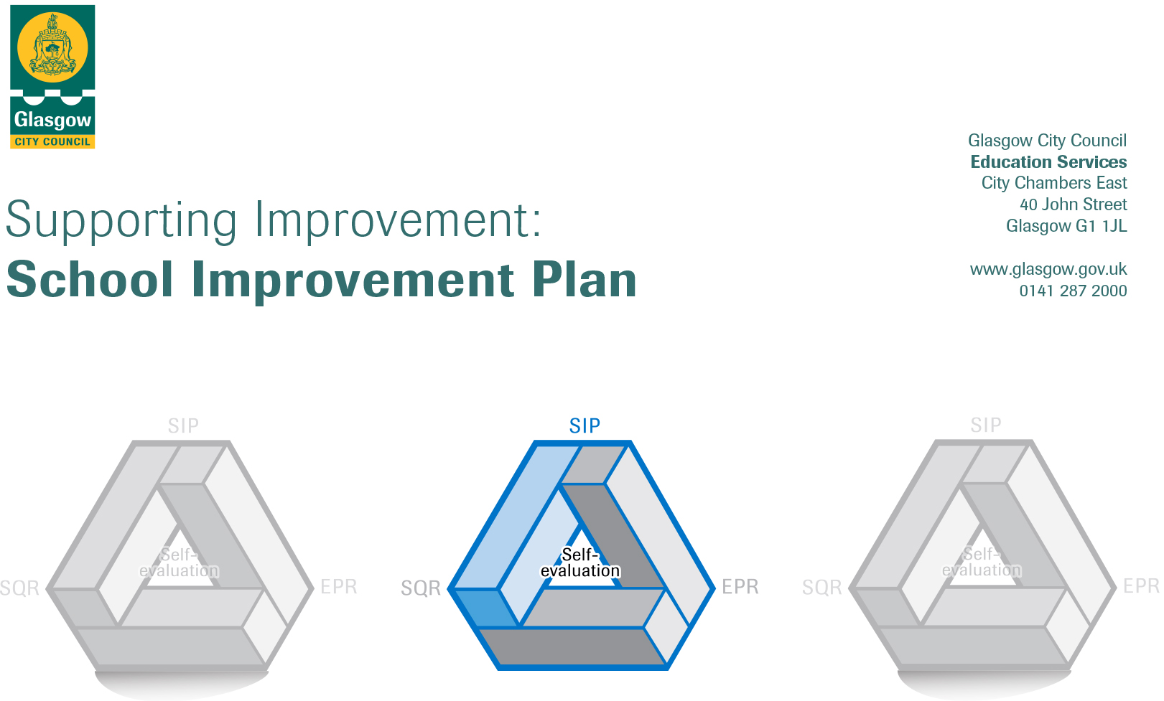

Establishment |  | Castlemilk Day Nursery
Head of Establishment |  | Karen Henderson  Samantha Nisbet (Acting Head)
Local Improvement Group |  | South LIG 3
Head of Service |  | Donnie MacLeod
Area Education Officer/
Quality Improvement Officer/Link Officer

CONTENTS
1. Vision, Values and Aims
2. Summary of Self-Evaluation Process / Priorities for Improvement in the current session
3. Additional Monies Spend Summary of Consultation Processes
4. Action Planning

Action Plan Summary for Stakeholders

1. Our Vision, Values and Aims
To offer a safe, happy, welcoming, and nurturing environment. An environment where children are offered high quality experiences in a curriculum rich setting, both indoors and outdoors. A setting that meets the needs and rights of every child promotes equality and inclusion and celebrates achievements.

We work together to:
- Create an environment where children, parents, families, and staff feel respected, Valued, and included.
- Encourage and support children to become, Successful Learners, Responsible Citizens, Effective Contributors and Confident Individuals.
- Build an environment where children are safe, healthy, achieving, nurtured, active, respected, responsible, and included. Support children in achieving their full potential.
- Promote the adoption of a healthy lifestyle and healthy life choices.
- Children’s choice is at the heart of this decision of outdoor play. Offering opportunity to play outdoors in all weather conditions.
- Promote positive behaviour by empowering children to take ownership of their own learning

2. Summary of our self-evaluation process.
At Castlemilk Day Nursery staff engage in a thorough self-evaluation process throughout the nursery year looking inwards, looking outwards and looking forwards directed by the quality assurance calendar activities. Self-assessment is an essential part of evaluation and presents opportunity to assess achievements and progression. Reflections and improvements are shared with parents, usually via our self-evaluation wall. Termly pace and challenge meetings ensure a robust self-evaluation of progress with a focus on attainment and meeting learners’ needs as well as identifying targeted support for improvement.

Staff work effectively as a team and there is a strong ethos of sharing practice, led and supported by the Senior Leadership Team. This session, staff took part in a moderation in-service day where they met with colleagues from other establishments to moderate work within literacy and numeracy outcomes.

Our self-evaluation incorporates views of children, parents, and multi-agency colleagues. All staff were offered the opportunity to reflect on improvements across the session looking inwards, looking outwards and looking forward. Staff identified strengths (How well are we doing?), relevant evidence (How do we know?) and improvement priorities (What are we going to do now?) in each area of the school improvement plan. Children and parents also have their views regularly sough through discussions, questionnaires and collecting data using online surveys. Children are also encouraged to share their learning through conversations with a member of management.

With the SLT being on door duty throughout the year, it provided opportunities for interactions with parents which offered numerous opportunities for feedback from parents.
Strengths identified:
The children are displaying an eagerness to learn, they are motivated and confident. They thrive in our nurturing environment, where they display positive social interactions with their peers and with adults. They are becoming successful in an environment that supports children’s choice and decision making.
We offer a range of stimulating and challenging experiences to support our children’s learning. We make good use of our outdoor area with free flow doors in playroom’s, placing choice at the heart of children’s decision when accessing outdoors. Our outdoors has a been a great asset during the pandemic and staff have placed an emphasis on outdoor learning for all children. Through the pandemic our nursery has had to be creative in meeting the needs of all our families. Regular development phone calls have been used to ensure clear communication with parents/carers in sharing successes and further development needs. The nursery also invested in a white board for outdoors to share updates and news with all families. Staff are using seesaw within the 3-5 room to share learning, updates and home link ideas. Digital technology has been used to capture learning and settling in for parents in the under 3 playrooms. This has allowed staff to show parents settled children and to celebrate the achievements of the children. Digital technology has also been used to create a PowerPoint for children’s rights that links Developing the Young Workforce, GIRFEC, Sustainable Development Goals, Meta Skills and UNCRC articles. This is an ongoing process that is being adapted and evaluated regularly. The children also took part in COP26 experiences, using the story of Winston of Churchill to enhance learning and understanding of sustainability. Videos and learning where shared with the LEL team as well as on Twitter.

Priorities for development:
1: Q.I 1.3- Leadership of Change (Embedding A Nurturing Approach in the Early Years)

2: Q.I 2.5 Family Learning (Raising the Attainment- literacy workshops, five to thrive and parental workshops)

3: Q.I 3.3- Developing skills for lifelong learning (Digital learning progression, SeeSaw)
4:

3. Additional Monies Spend Summary of Consultation Processes
Rationale for Spend:

Measures/Evidence for Impact (data, observation, views):
1:

2:

3:

4:

4. Action Planning

No. | Quality Indicator | Priority
1 | 1.3 | Leadership of Change (Embedding A Nurturing Approach in the Early Years)

Tasks to achieve priority | Timescale  and checkpoints | Evidence of Impact > (data, observation, views)
Getting ready for Nurture Checklist | August 2022  December 2022  April 2022 | By 2023 it is envisioned that every Early Years setting will undertake training in five to thrive, nurture and child development. As a centre, we will complete the Getting ready for Nurture checklists, issued by the Educational Psychologist Team to determine the readiness for the Nurture programme.  A quality assurance calendar of self- evaluation using challenge questions will be devised for the year focusing on our current SIP. Links to UNCRC and National Care Standards will be included, as well as the Nurture Principles for a focus of the month. This will ensure staff have a sound understanding of the knowledge behind the principle and can put this into practice.  Completing the checklist prior to starting the programme will allow for a baseline to measure against in further evaluations throughout the school year. When looking at leadership and our approach to improvement we aim to delegate leadership roles within staff team. There will be a focus group of staff who will attend training and cascade back to colleagues during in-service days or twilight sessions.
Nurture Focus Group within and out with the centre | September 2022  December 2022  March 2023  June 2023 | A working group of Nurture will meet regularly collating evidence in relation to quality assurance calendar, with identified steps for improvement. Identification of needs of staff following observation; consistency of approach to nurture observed throughout the nursery. Impact on learners – calmer pupils; increased attainment.  The feedback will inform practice and future developments.  Children will be consulted through their children rights forum ensuring UNCRC article 12 is enacted.
Whole School approach to Nurture training and modules | August 2022  October 2022  Feb 2023 | Staff will complete the online modules; these include a mixture of content and activity-based learning. The modules will allow for staff to engage in group discussions and reflections and will help link knowledge with practice. Data analysis will identify priority nurture principle to focus on throughout term. An action will be created to embed this within the establishment. The LPA is also completing modules as part of project; this will ensure nurture and raising the attainment is a streamlined process. The data will give us a more holistic insight when gathering self-evaluation for improvement.

Staff leading on this priority – including partners | Resources and staff development
HoC will lead the Focus group  LPA  Glasgow Psychological Services | EP input for Nurture modules and training  Whole School Approach to Nurture Training

No. | Quality Indicator | Priority
2 | 2.5 | Family Learning (Raising the Attainment- literacy workshops, five to thrive and parental workshops)

Tasks to achieve priority | Timescale  and checkpoints | Evidence of Impact > (data, observation, views)
August Inset day, all staff will receive training on GCC literacy for all trackers and literacy back pages. This will be delivered by our LPA and LEL. | August 2022 | Closing the attainment gap is a key driver in Scottish education and one which can be assisted through literacy to help create a culture of aspiration in families Raising attainment and achievement through Glasgow’s improvement challenge will still be the focus. The framework makes clear link CFE benchmarks. Improvement Framework and the Scottish Attainment Challenge aim to reach the most disadvantaged families and deliver early intervention and prevention programmes such as literacy.
Targeted Intervention Groups identified and implemented through tracking at start of term with LPA and keyworkers | August 2022  November 2022  May 2023 | Tracking data- interim assessments to determine progress  Tracking meetings  Ongoing assessments in specific area of intervention Increased attainment in literacy.  Impact should show children are on track to achieving early level by end of primary1.
Guidance and implementation of the moderation cycle, specifically gathering evidence to further support tracking data and teacher judgement against benchmarks and Literacy for All | August 2022  October 2022  February 2023 | Increase staff confidence  Tracking conversations Data analysis Increased confidence in practitioner professional judgment.
Introduction of Parent Literacy Workshops | September 2022- ongoing | Tracking and monitoring the levels of attendance of parents/carers.  Parents/carers will gain knowledge of how to Increase family’s participation in their child’s life.  Understanding of the benefits of partnership working and educational outcomes to promote learning.  Children’s confidence will be boosted and there is a positive impact on their development. Links to the Getting it Right for Every Child.
Re-introduce Five to Thrive home learning bags with the under 3 rooms | September 2022 | Through children’s individual literacy trackers data will record children’s progress.  Feed back through questionnaires, self-evaluation.  Data gathered from baseline on parental engagement with percentage on parent/carers returning the completed evaluations of the bags.

Staff leading on this priority – including partners | Resources and staff development
LEL and LPA  Melanie for Five to Thrive with support from Depute  Literacy focus group  Team leader will support LPA | Literacy training using Trackers recording Data  Literacy for All Resource/Trackers  LEL/LPA delivering training  Birth to three Trackers  Monitoring/Moderation paperwork  Five to Thrive home learning bags  Questionnaires for parents/baseline assessments

No. | Quality Indicator | Priority
3 | 3.3 | Developing skills for lifelong learning (Digital learning progression, SeeSaw)

Tasks to achieve priority | Timescale  and checkpoints | Evidence of Impact > (data, observation, views)
Refresh the nursery Digital Strategy | September 2022  February 2023 | Create as whole staff team approach digital learning strategy.  In house training twilight.  All practitioners will be confident in using I pads and will be part of curriculum learning for children.  Children can take ownership of their learning through the use of digital technology.
SeeSaw training for under 3 staff | August 2022  Ongoing, as when needed | Staff increased confidence using SeeSaw  Measuring and monitoring parent engagement with child’s learning  Children will have more ownership of learning  Staff will have better understanding of how to use digital technology to promote and showcase children’s learning
Introduction of Framework for Digital Literacy and Computing Science Trackers for 3-5 | October 2022  February 2023  May 2023 | Improved learner experiences in digital technology and computing science.  Staff will have increased confidence using the framework and can talk about it.
Using digital technology for routines; story telling, playdough making etc | September 2022  November 2022  January 2023  April 2023 | Staff will use digital technology to enhance children’s learning  Children will be able to use iPads to develop independence skills.  Children will learn about QR codes and how they work  Staff will become more confident thinking innovatively to develop skills

Staff leading on this priority – including partners | Resources and staff development
Head of Centre
DLOL and all staff
Partnership for story telling

No. | Quality Indicator | Priority
4

Tasks to achieve priority | Timescale  and checkpoints | Evidence of Impact > (data, observation, views)

Staff leading on this priority – including partners | Resources and staff development

